











































    















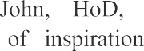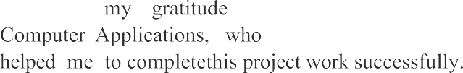



**ABSTRACT OF CINEMAPHILE**

**Name of the Project:** Movie Rating System

Online reviews and ratings are considered extremely important in any business especially Film Industry. Any person who wants to choose a best Movie Right Now will check ratings.The Boxoffice Verdict of Movie Depends on its Rating and Reviews.The Audience who are Going to watch a Movie Definetly will check the rating of that particular Movie,if the Audience Finds Movie Not according to there Taste then they can easily Go for another Movie Which they like.

In Movie rating system users are allowed to rate and comment on movies that They watched,the other users can view Those Reviews.Based on the ratings Given From Multiple Users The System will Give an Average Rating To That Movie Where all Users can View.

The system Have an Admin who Regularly updates New Movies with There Plot,where users rate it.

It allows normal users to avail for view the movie details and comment on it.Admin will add the movie details up to date to users view.user can view about the movie and rate them and comment on it for users view about the movie.This software helps user to deliver and see quality movies.

## STATEMENT ABOUT PROBLEM

We often encounter online movie rating sites, where the admin manually rates the movie, depending upon the comments, ratings and reviews of the users.This causes users to belive it and go waste money on it.

Some problems are:

* In busy life user donot get the time to investigate on verdict of different movies
* From day to day releasing movies user donot know what they like and what they want to watch
* But the problem is if a user ask to 10 people ,the 10 people may have 10 opinions,so its very difficult for the user to predict the actual verdict about

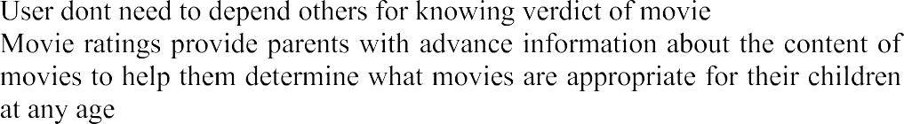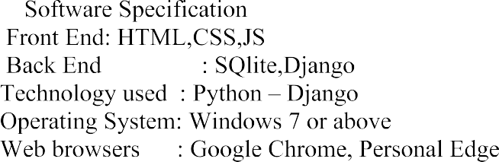



## CONTRIBUTION THAT THIS PROJECT MAKES

Since this project will be developed for Movie Lovers it can be used by various booking Ticket booking sites to promote the movie.it can also be used by various OTT services to Know the current rating of movie.

























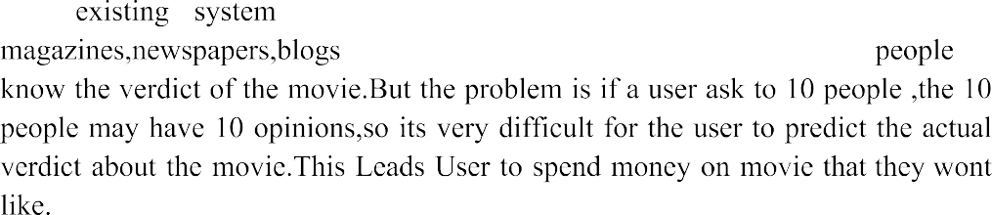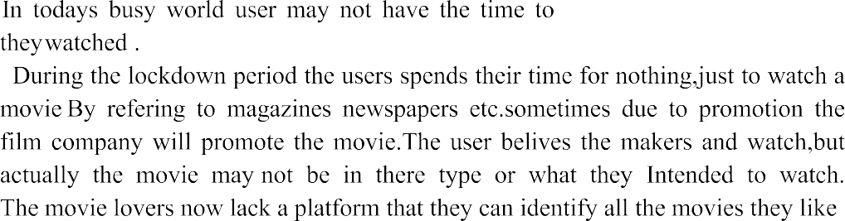

CINEMAPHILE 3

* 1. ***PROPO S E D SYSTEM***

The propose system is highly automated and allows the user to search for the vast variety of Movies and allows the users to choose the best Movie that satisfies there expected rating and reviews. The Users can be entered using a usemame and password. Only Admin can change the data or to add more information data to the database. These data can be retrieved easily. The interface is very user friendly. Thedata and the admin details are well "Protected" and "Personalized" to makes thedata processing very fast.

### FEATURES OF PROPO S E D SYSTEM

* User can view all the movies in the system
* User can view the total rating of that movie from all the ratings counted
* User can view the reviews of various users about that movie
* User can rate the movie
* User can add review to the movie
* User can add movie to watch list so they can watch later
* User can view all movies in a particular genre that the admin added

Department of Computer Application **MCKA**





CINEMAPHILE 5

### Administrative Function

The Ad.min Must able to Login to the System and control all the administrative functionalities of the system.only admin should be able to acces the administrative functionalites,all other users should be Not able to acces the functionality

### User registeration

The system must allow non registered users to create a secure account.sytem shall ask for usemame and password.The information shall store in database.Information such as firstname,lastname,mobile number should be kept securely.

### User Authentication

The System shall allow Registered user to log in to their account.The system must verify there usemame and password with the information in database.only that user should be able to login with that usemame and password.

### Add movie details

ts an admin functionality,the admin must able to add various movie details and it must be stored in the database concurrently.

### View movie details

The movie details in database must be available in home page of userand users can visualize the details in an interactive way.

### Delete movie

Ad.min should have the functionality to Delete the movie.

Department of Computer Application MCKA





CINEMAPHILE 7

# NON FUNCTIONAL REQUIREMENTS

Department of Computer Application MCKA





CINEMAPHILE 9

# UML DIAGRAMS

Department of Computer Application MCKA









 



            
            
            
            

























































